# Data set:

I took the dataset from <https://www.kaggle.com/mastmustu/weather-analysis/version/1>

# Importing Libraries:

I used the following libraries in my code:

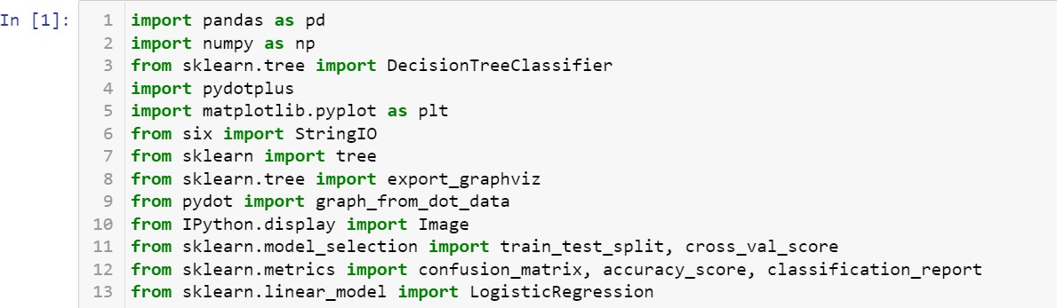

# Reading the Dataset:

First, I had to read the data so I printed its first five values of every column or feature to give an idea of it. I have also printed the number of rows in the dataset which comes out to be 3902.

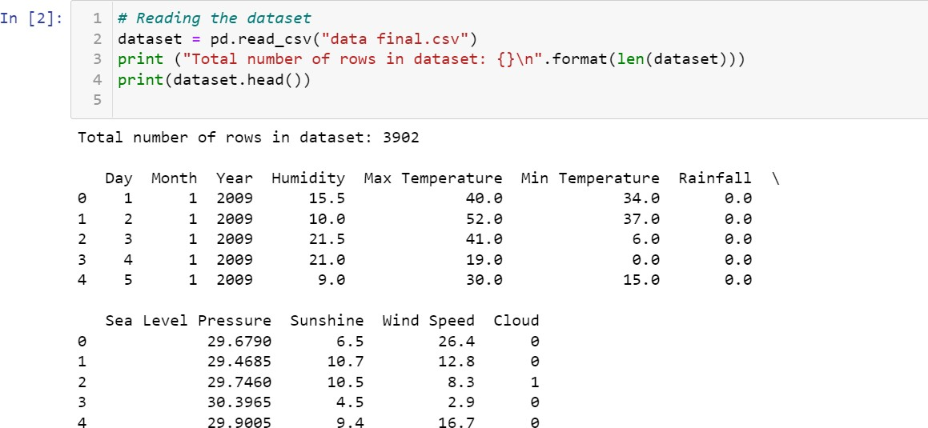

# Cleaning the Dataset and removing the Null data:

Now, we have to clean the dataset by making sure if there are zeros or empty values so we assign them random values according to their columns and clean the data in this way. And I removed the extra features which weren’t required from the dataset by deleting them. I also removed the null data by using the isnull() function.

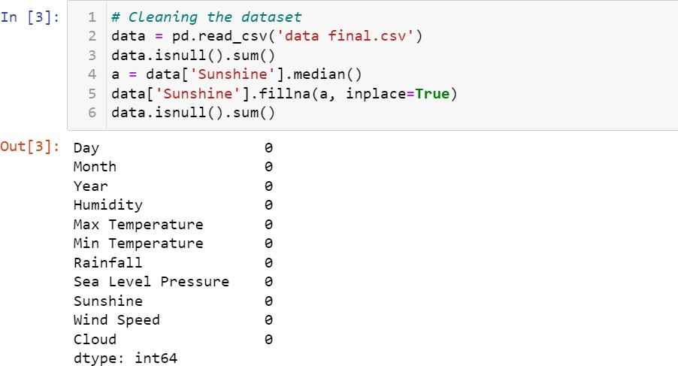

# Initializing Features:

Then I initialized the given features in the dataset and initialized some other variables to be used in the logistic regression and decision tress.

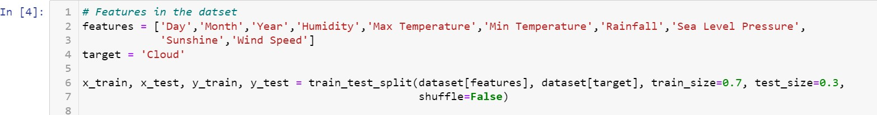

# Decision Tree Classifier Model:

Then I coded for the decision tree classifier model which is as below:

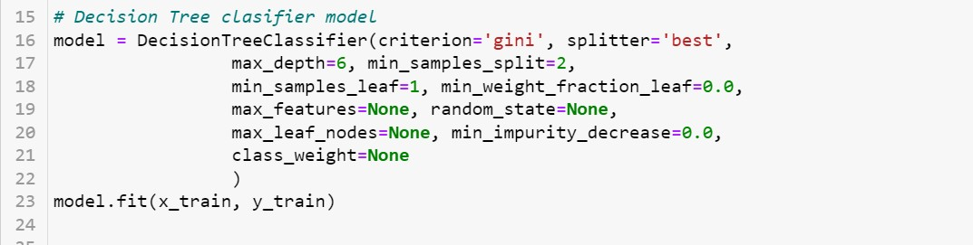

# Results of the decision tree classifier model:

I printed the training and the testing set accuracy by using the decision tree classifier model and got the results as:

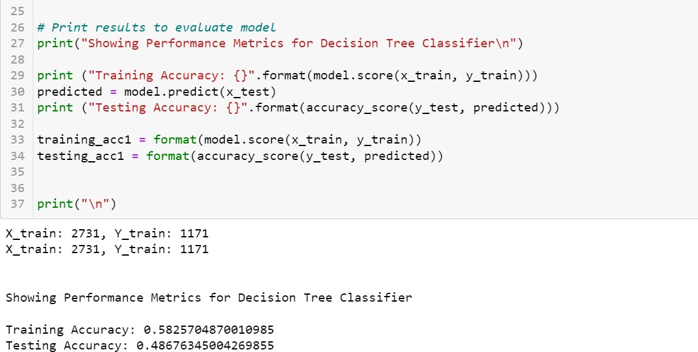

# Making a Decision Tree:

Then I made a decision tree (a graph) which is as follows:

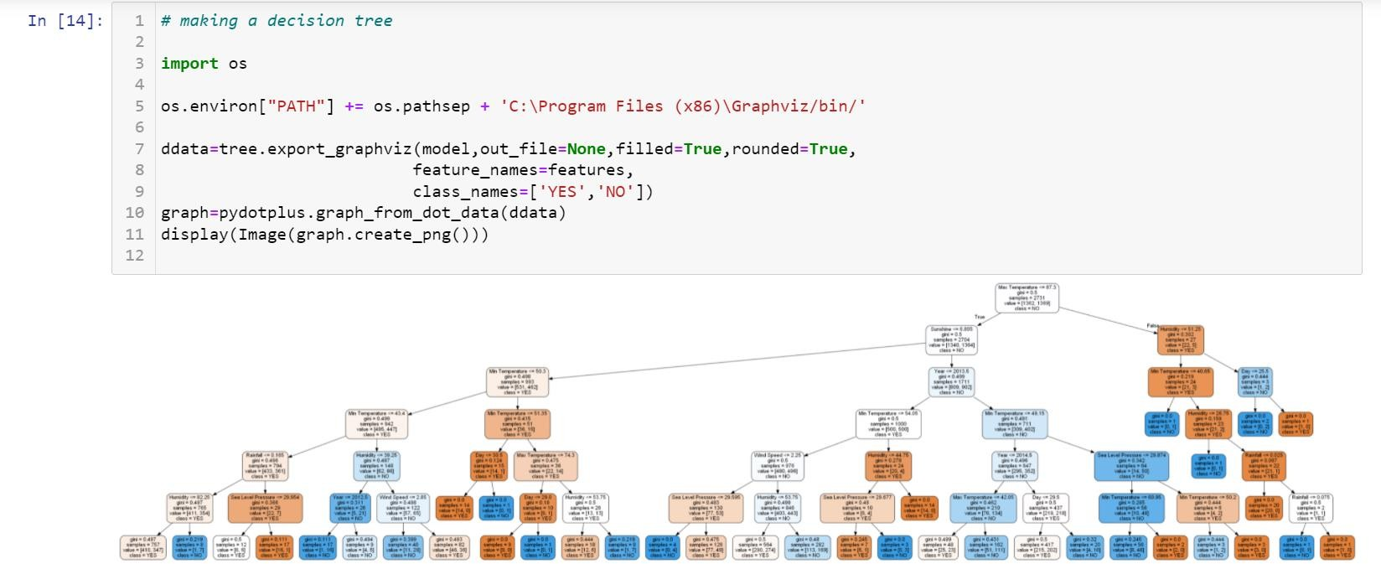

# Logistic Regression:

I also did the logistic regression on the dataset as:



# Results of the Logistic Regression:

The results of the logistic regression we get are the following as of the training and testing accuracies:

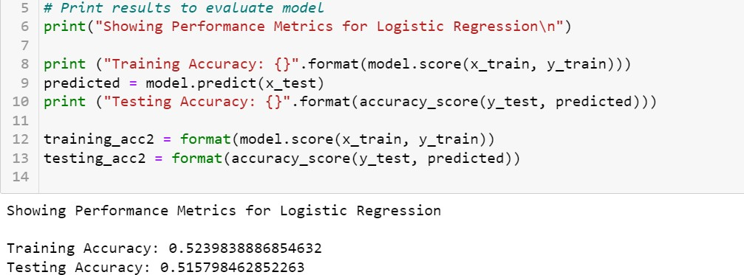

# Comparison between two Data mining methods:

I compared the accuracies given by decision tree model and the logistic regression as:

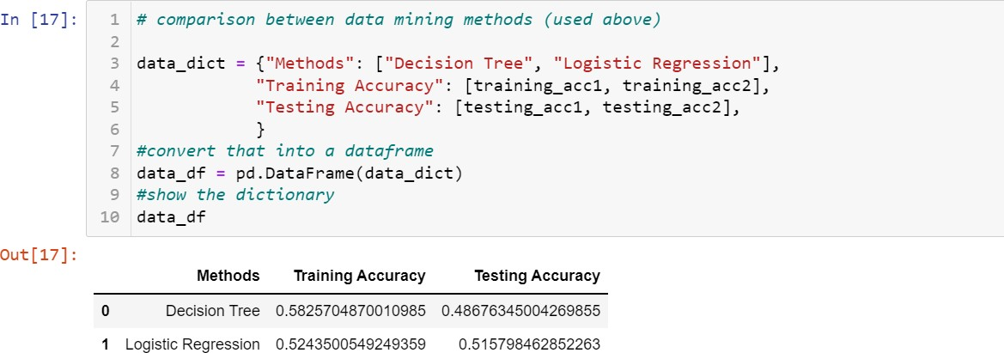

# Comparison between two Data mining methods using Bar Graph:

I have used the bar graph to show their comparison as:

